**CHAPTER 1**

**Introduction**

* 1. **Introduction to WEB**

The World Wide Web (WWW), also called the Web, is an information space where documents and other web resources are identified by Uniform Resource Locators (URLs), interlinked by hypertext links, and accessible via the Internet. English scientist Tim Berners-Lee. Invented the World Wide Web in 1989. He wrote the first web browser in 1990 while employed at CERN near Geneva, Switzerland. The browser was released outside CERN in 1991, first to other research institutions starting in January 1991 and to the general public on the Internet in August 1991.

The World Wide Web has been central to the development of the Information Age and is the primary tool billions of people use to interact on the Internet. Web pages are primarily text documents formatted and annotated with Hypertext Mark-up Language (HTML). In addition to formatted text, web pages may contain images, video, audio, and software components that are rendered in the user's web browser as coherent pages of multimedia content.

* 1. **HTML**

Hypertext Mark-up Language (HTML) is the standard mark-up language for creating web pages and web applications. Web browsers receive HTML documents from a web server or from local storage and render the documents into multimedia web pages. HTML describes the structure of a web page semanticallyand originally included cues for the appearance of the document.

HTML elements are the building blocks of HTML pages. With HTML constructs, images and other objects such as interactive forms may be embedded into the rendered page. HTML provides a means to create structured documents by denoting structural semantics for text such as headings, paragraphs, lists, links, quotes and other items. HTML elements are delineated by tags, written using angle brackets. Tags such as <img /> and <input /> directly introduce content into the page. Other tags such as <p> surround and provide information about document text and may include other tags as sub-elements. Browsers do not display the HTML tags, but use them to interpret the content of the page.

* 1. **PHP**

PHP: Hypertext Pre-processor (or simply PHP) is a server-side scripting language designed for Web development, and also used as a general-purpose programming language. It was originally created by Rasmus Lerdorf in 1994; the PHP reference implementation is now produced by The PHP Group. PHP originally stood for Personal Home Page, but it now stands for the recursive initialism PHP: Hypertext Pre-processor.

PHP code may be embedded into HTML code, or it can be used in combination with various web template systems, web content management systems, and web frameworks. PHP code is usually processed by a PHP interpreter implemented as a module in the web server or as a Common Gateway Interface (CGI) executable. The web server combines the results of the interpreted and executed PHP code, which may be any type of data, including images, with the generated web page. PHP code may also be executed with a command-line interface (CLI) and can be used to implement standalone graphical applications.

The standard PHP interpreter, powered by the Zend Engine, is free software released under the PHP License. PHP has been widely ported and can be deployed on most web servers on almost every operating system and platform, free of charge.

* 1. **Javascript**

JavaScript often abbreviated as JS, is a high-level, interpreted programming language. It is a language which is also characterized as dynamic, weakly typed, prototype-based and multi-paradigm.

Alongside HTML and CSS, JavaScript is one of the three core technologies of the World Wide Web. JavaScript enables interactive web pages and thus is an essential part of web applications. The vast majority of websites use it, and all major web browsers have a dedicated JavaScript engine to execute it.

Initially only implemented client-side in web browsers, JavaScript engines are now embedded in many other types of host software, including server-side in web servers and databases, and in non-web programs such as word processors and PDF software, and in runtime environments that make JavaScript available for writing mobile and desktop applications, including desktop widgets.

* 1. **SQL**

SQL is a language to operate databases; it includes database creation, deletion, fetching rows, modifying rows, etc. SQL is an ANSI (American National Standards Institute) standard language, but there are many different versions of the SQL language.

What is SQL?

SQL is Structured Query Language, which is a computer language for storing, manipulating and retrieving data stored in a relational database.

SQL is the standard language for Relational Database System. All the Relational Database Management Systems (RDMS) like MySQL, MS Access, Oracle, Sybase, Informix, Postgres and SQL Server use SQL as their standard database language.

**CHAPTER 2**

**Literature Survey**

**2.1) EXISTING VS PROPOSED SYSTEM**

Existing Systems consists of only the Computer details such as, Number of Systems and IP address etc.. It does not have any centralized and separate website for Cafe Management

In existing system admin can view only the IP address of the particular System which are searched by the users. In that people cannot get to know which is system is available currently for the use. This is the main drawback of the existing system. And also this is the main disadvantage of the Users those who are in need of Occupying Systems.

The online Cyber Cafe Management system is developing to facilitate the Users. Here Admin visit the website by registering His details.

After that the registration process got over He can enter into the site. They can view the System details .those who is willing to Occupy System Of the Cafe can pay amount by giving their details such as name, Identity proof etc…

As soon as admin receives that particular amount from the user, response message will be sent to the user’s mail. Amount which is given by the users will be sent to the admin account. Admin will transfer that particular amount of time to user who have been registered. Adding the new computers to the Cafe, viewing the user details, updating the database these are the jobs of the admin.

**CHAPTER 3**

**REQUIREMENTS AND SPECIFICATION**

**Purpose of requirements document**

The software requirement specification is the official statement of what is required for development of particular project. It includes both user requirements and system requirements. This requirement document is utilized by variety of users starting from project manager who gives project to the engineer responsible for development of project.

It should give details of how to maintain, test, verify and what all the actions to be carried out through life cycle of project.

**3.1 Hardware Specification**

• PROCESSOR: Pentium 4 or higher (1.2GHz or higher).

• RAM: 2GB or higher.

• HARD DISK: 15GB or higher.

• MONITOR: 15”CRT or LCD monitor.

• KEYBOARD: normal.

• MOUSE: compatible mouse.

**3.2 Software Specification**

• OPERATING SYSTEM: Windows 7 or later versions.

• LANGUAGES: JavaScript, HTML, SQL.

• FRONT-END TOOL: HTML, JAVASCRIPT, CSS, PHP

• BACK-END TOOL: MySQL database

• SERVER: apache (AMP)

• SOFTWARE: XAMPP

**CHAPTER 4**

**SOFTWARE REQUIREMENT SPECIFICATIONS (SRS)**

Requirements specification is very important activity after the problem definition. This is the way to represent requirements in a consistent format. Requirements specification is called Software Requirements Specification (SRS).

The SRS is a specification for a particular Software product, program or set of programs that performs certain functions in a specific environment. It servers a number of purposes depending on who is writing it. First, the SRS could be written by the customer of the system. Second, the SRS could be written by a developer of the system. The two scenarios create entirely different situations and establish entirely different purposes for the document. First case, SRS is used to define the needs and

expectations of the users. The second case, SRS is written for different purpose and serve as a contract document between customer and developer.

The Requirements are broadly divided into two groups:

➢ Functional requirements

➢ Non-functional requirements

**Functional Requirements:**

The main purpose of functional requirements within the requirement specification document is to define all the activities or operations that take place in the system. These are derived through interactions with the users of the system. A summary of major functions that the software will perform

➢ A Login facility for enabling only authorized access to the system.

➢ Admin able to add/modify/delete information about System and topics.

➢ Admin will be able to add/modify/delete information of users.

➢ Admin will be able to generate printable reports.

➢ Admin will be able to create/modify/delete existing user accounts.

**Non-Functional Requirements:**

The non-functional requirements consist of

i. Guidelines.

ii. Validation Criteria.

**Guidelines:**

We have discussed mandatory requirements in the previous section. The requirements in this section should be taken as suggestions & they should be thought of as recommendations to further enhance the usability of the system.

➢ The system should display a home page for users to choose.

➢ The system should display user’s requests in a reasonable time.

➢ The system should be designed in such a way that it is easy to enhance it with more functionality. It should be scalable and easily maintainable.

**Validation Criteria:**

➢ Only Admin will have access to the system.

➢ Admin will have a unique Admin id.

➢ Admin id cannot be blank.

➢ Admin Password cannot be blank.

**CHAPTER 5**

**SYSTEM DESIGN**

**5.1 System Perspective**

Systems design is the process of defining the architecture, modules, interfaces, and data for a system to satisfy specified requirements. Systems design could be seen as the application of systems theory to product development. There is some overlap with the disciplines of systems analysis, systems architecture and systems engineering.

Systems theory is the interdisciplinary study of systems. A system is a cohesive conglomeration of interrelated and interdependent parts that is either natural or man-made. Every system is delineated by its spatial and temporal boundaries, surrounded and influenced by its environment, described by its structure and purpose or nature and expressed in its functioning. In terms of its effects, a system can be more than the sum of its parts if it expresses synergy or emergent behaviour. Changing one part of the system usually affects other parts and the whole system, with predictable patterns of behaviour.

Some systems function mainly to support other systems by aiding in the maintenance of the other system to prevent failure. The goal of systems theory is systematically discovering a system's dynamics, constraints, conditions and elucidating principles that can be discerned and applied to systems at every level of nesting, and in every field for achieving optimized equifinality

**5.2 ER Diagram**

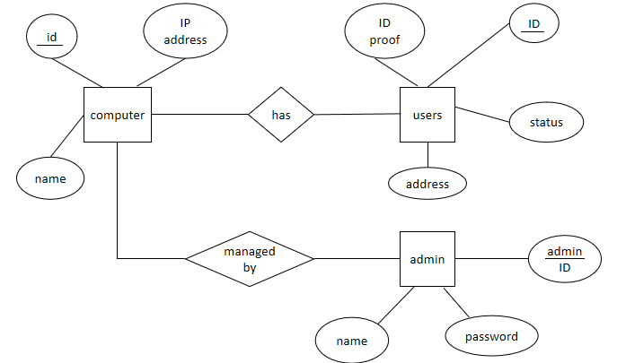

Fig 5.2.1: ER Diagram

**CHAPTER 6**

**IMPLEMENTATION**

Implementation mistresses of software development project developers actually input the source code into computer that will be compiled into the final software program. Source code is high level language (i.e. html, database.) that is typed into an IDE (interactive development environment) and stored in a text file on the computer. This text file is compiled into machine code, which are the instruction actually understood by the computer.

The design and implementation of any, automated system greatly depend upon the quality of software used to design such system. For the purpose of this computerization process. HTML was used for the design. This programming language was opted for due to the aesthetic user inter-phase feature it offers and i. flexibility. The program is compatible with other programming language or customized application such as HTML which was used in creating the database for the proposed system. SQL was chosen because it is a relational database management system; it is fast and easy to implement. Generally, the implementation of a system refers to the transformation of the system specification designed from the originally obtained requirement, into program codes. The implementation of this system, involved the writing of programs in visual basic language.

**CHAPTER 7**

**DESIGN AND ANALYSIS**

The analysis of the role of a proposed system and the identification of the requirements that it should meet. System Analysis is the starting point for system design. The term is most commonly used in the context of commercial programming, where software developers are often classed as either systems analysts or programmers. The systems analysts are responsible for identifying requirements (i.e. systems analysis) and producing a design. The programmers are then responsible for implementing it.

Software development is a challenging activity. Today the systems are steadily growing in size. They are progressively becoming more complex. User requirement becoming are tending to be dynamic in nature, challenging technical scenario shorter dead times and no availability of personal make. The task of development more challenging as the management always depends upon accurate and timely information and arises for powerful tool, which could process data from different areas, interconnected and produce the information in time. The proposed system contains the following: --

❖ Error can be avoided.

❖ Data interpretation, processing and maintenance can be done effectively.

❖ Data validation is performed at necessary stage.

❖ A separate database for every form is available.

❖ Search option is provided whenever required.

❖ Time effective & easy processing

❖ Flexible to make changes & can be used for a long time.

**CHAPTER 8**

**TESTING**

**Software Testing**

Software testing is an investigation conducted to provide stakeholders with information about the quality of the product or service under test. Software testing can also provide an objective, independent view of the software to allow the business to appreciate and understand the risks of software implementation. Test techniques include, but are not limited to, the process of executing a program or application with the intent of finding software bugs (errors or other defects).

**8.1 Types of Testing:**

**Block Box Testing**

Black-box testing tests functional and non-functional characteristics of the software without referring to the internal code of the software. It uses external descriptions of the software like SRS (Software Requirements Specification), Software Design Documents to derive the test cases. The validation (Project design and play), verification (Accessing application in multiple system throughout the organization), and general usability testing’s (User interface, Bug free and faster access).

**White Box Testing**

The proposed application contains various different modules and integrated successfully. All independent paths within a module, logical decisions, loops at their boundaries and within their operational bounds and Database internal data structures and validations are working as per the client requirements.

**8.2 Test Cases**

Test Cases are such elements in software testing which are used to determine whether the output obtained is in the expected one or not.It is just similar to that of trial and error but with some disciplinary documentation and principal proceedings. Some of the test cases are conducted and are recorded below regards the project.

|  |  |  |  |  |  |
| --- | --- | --- | --- | --- | --- |
| Case_id | Description | Input Data | Expected Output | Actual Output | Status |
| 1 | Enter the  Information For  Login | Valid  username and  password | Log in | Logged in | Pass |
| 2 | Enter Information  For Registration | User name  Password  Email, phone  No. | Account should  be Created | Account Created  successfully | Pass |
| 3 | Manage Computers | Add computer | Computer should added | Computer Updated | Pass |

Fig 8.1: Test Cases

**CHAPTER 9**

**SNAP SHOTS**

1. Admin Login Form

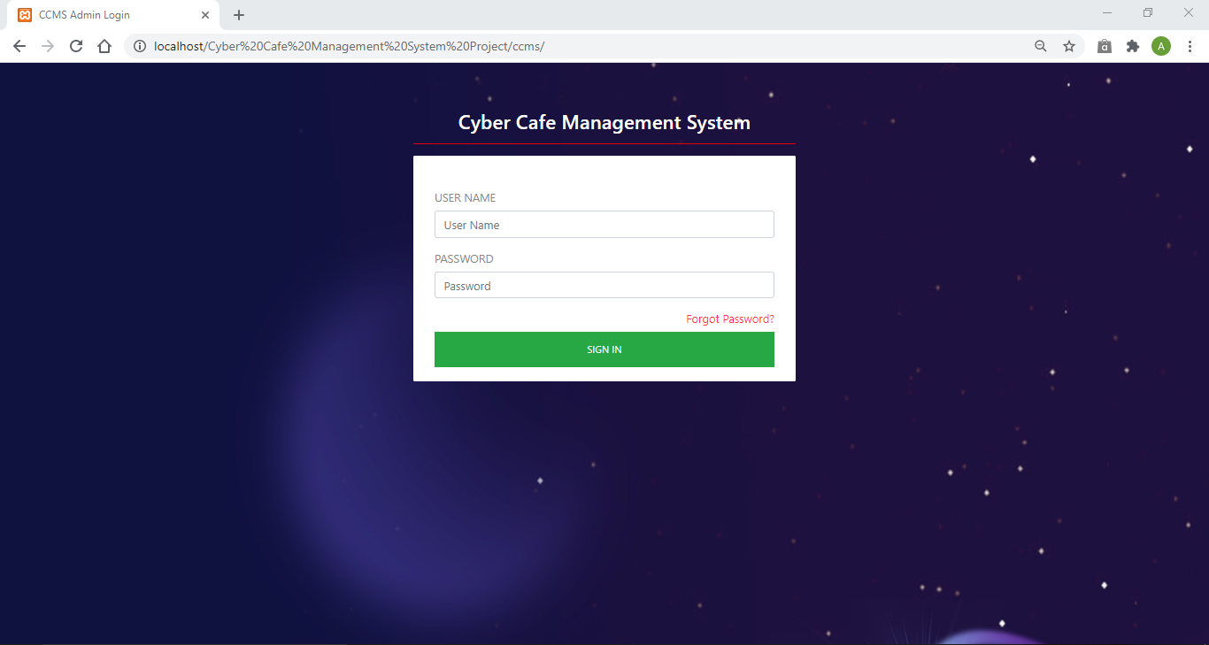

Fig 9.1: Admin Login Form

1. Admin Account panel

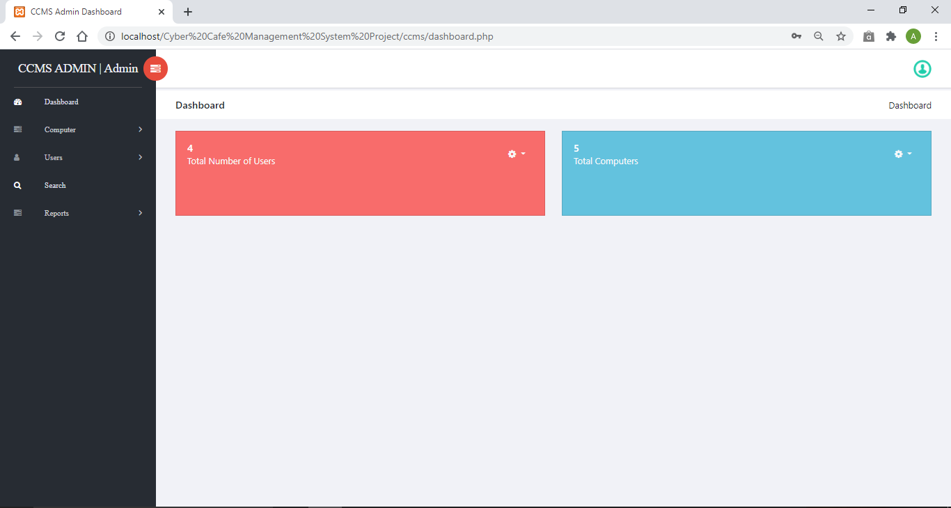

Fig 9.2: Admin Account panel

3. Add Computer

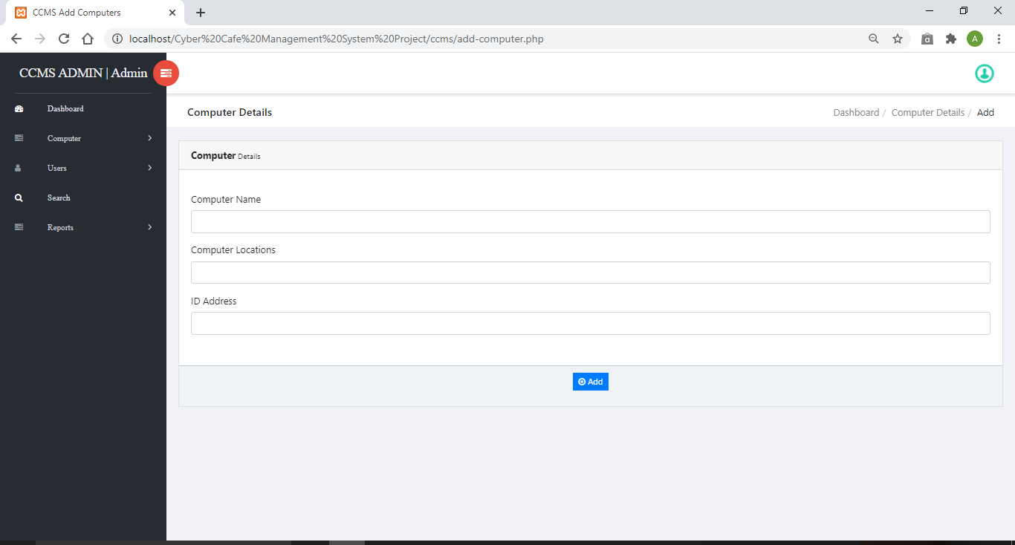

Fig 9.3: Add Computer

4.Manage Computer

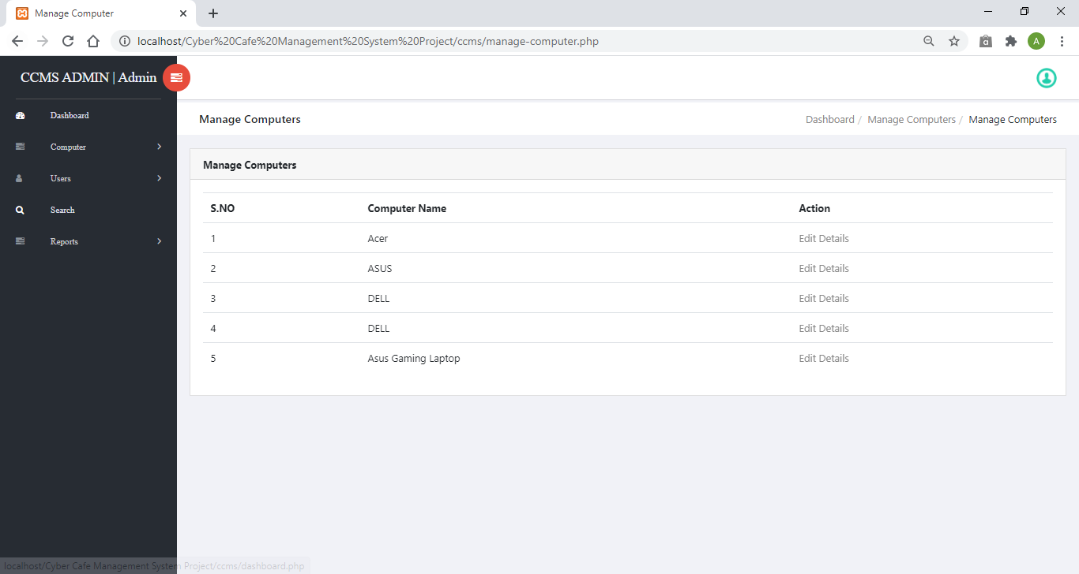

Fig 9.4: Manage Computer

5.Add User

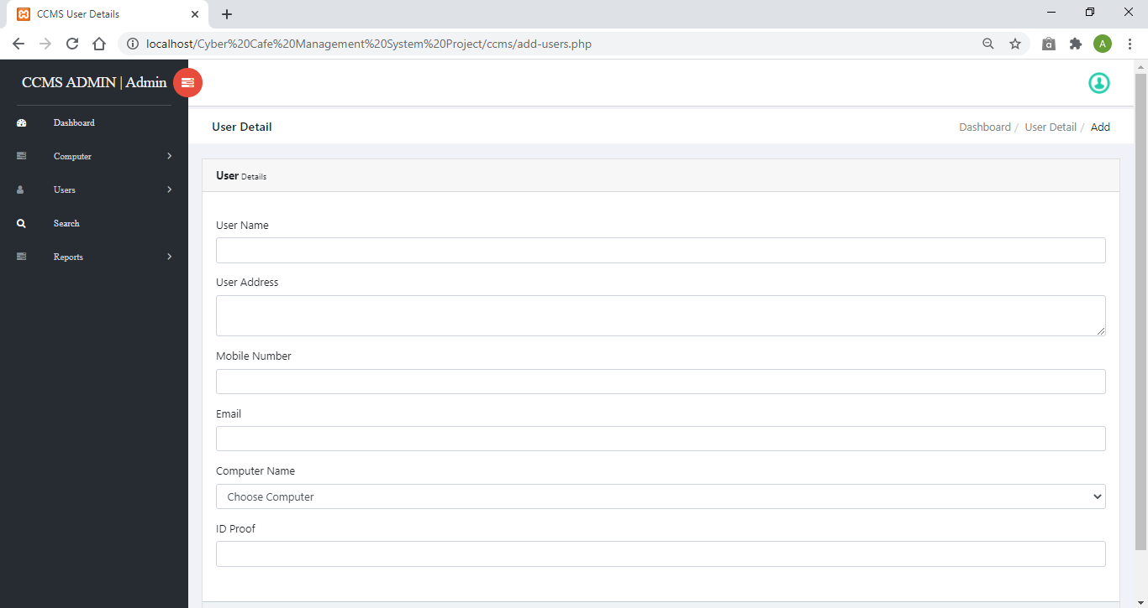

Fig 9.5: Add User

6.Manage Old User

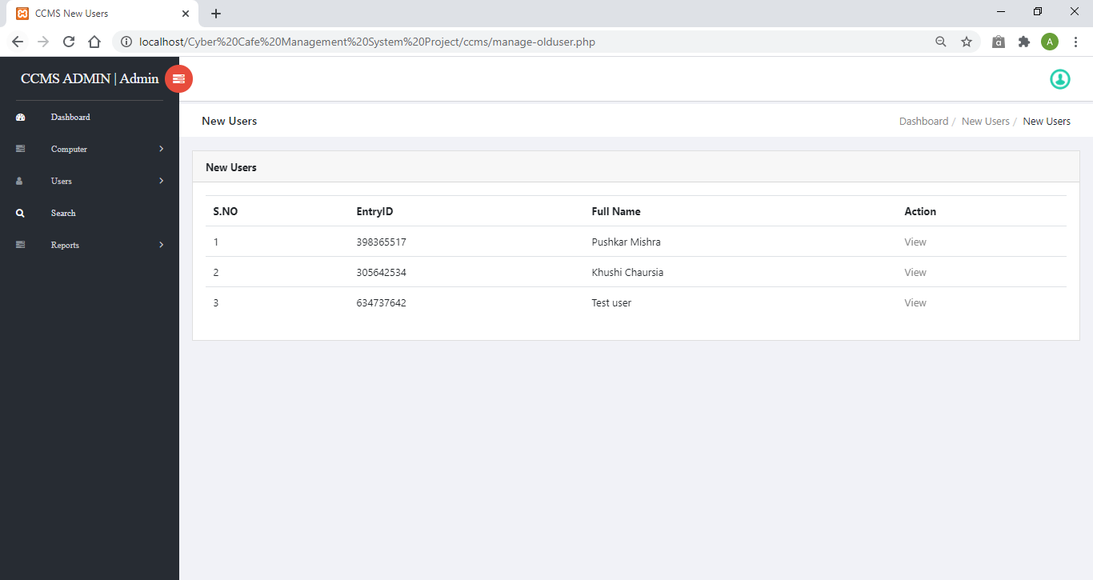

Fig 9.6: Manage Old user

7.Dates Reports

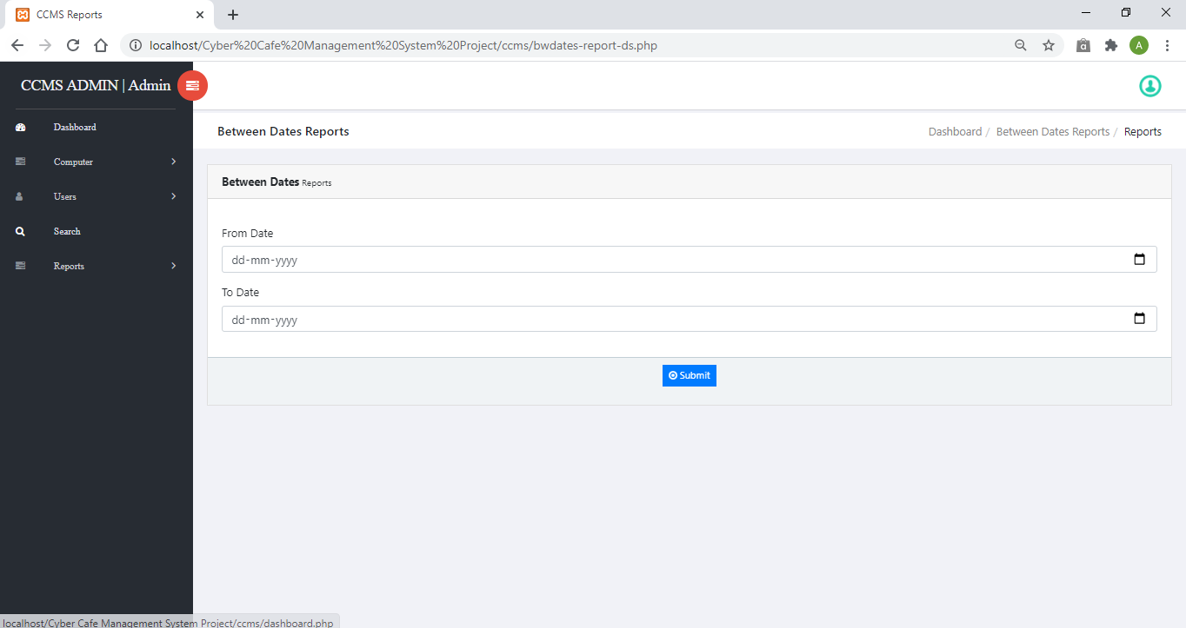

Fig 9.7: Dates Reports

**CONCLUSION**

This website provides a computerized version of Cyber Cafe management system which will benefit the Admin as well as the Users.

Cyber Cafe is the name to describe a residential institution devoted to the care of Cyber centre and the user . This project’s purpose is to change the conventional manual management to the computerized management system. The system should be implemented to facilitate easy and effective registration of user.

**REFERENCES**

* *Google for problem solving.*
* *<https://www.youtube.com/>*
* *Database Programming with PHP*
* *<http://www.php-tutorial.com/>*
* *<http://www.w3schools.com/>*
* *<https://github.com/>*
* *<https://docs.oracle.com/>*
* *[www.mysql.com/](http://www.mysql.com/)*
* *Coding with Javascript for Dummies by Wiley publications .*
* *HTML & CSS: The Complete Reference,Thomas A Powell .*
* *MySQL(TM): The Complete Reference,Vikram Vaswani .*